Home Work 3 Awais Afridi 876741

Q1: The accompanying table shows hypothetical demand and supply schedules for milk per year. The U.S. government decides that the incomes of dairy farmers should be maintained at a level that allows the traditional family dairy farm to survive. So it implements a price floor of $1 per pint by buying surplus milk until the market price is $1 per pint.

|  |  |  |
| --- | --- | --- |
| Price | Quantity demanded | Quantity Supplied |
| $1.20 | 550 | 850 |
| $1.10 | 600 | 800 |
| $1.00 | 650 | 750 |
| $0.90 | 700 | 700 |
| $0.80 | 750 | 650 |

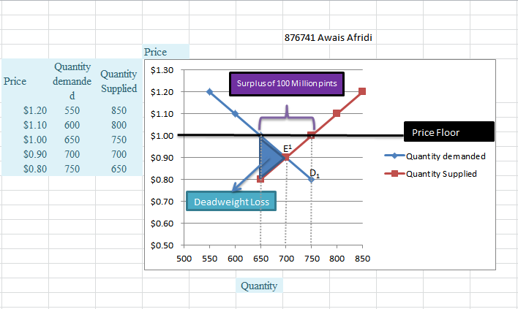a) In a diagram, show the deadweight loss from the inefficiently low quantity bought and sold.

b) How much surplus milk will be produced as a result of this policy?

With demand of D1 and supply of S, the equilibrium would be at point E1 in the accompanying diagram. However, with a price floor at $1, the quantity supplied is 750 million pints and the quantity demanded is 650 million pints. So the policy causes a surplus of milk of 100 million pints per year.

c) Explain how inefficiencies in the form of inefficient allocation to sellers and wasted resources arise from this policy.

As we know that the surplus is 100 million and if farmers want to sell them they have to sell it on lower price than price floor but they can’t do it because it will be violation of law. So due to this problem many farmers will financial loss, and the the amount of 100 million pints will get wasted.

Q2: The French government sets minimum starting yearly wages for new hires who have completed *le bac*, certification roughly equivalent to a high school diploma.  
The demand schedule for new hires with le bac and the supply schedule for similarly credentialed new job seekers are given in the accompanying table. The price here is the same as the yearly wage.

|  |  |  |
| --- | --- | --- |
| Wages  (in euro per year) | Quantity demanded  (new job offers per year) | Quantity supplied  (new job seekers per year) |
| 45,000 | 200,000 | 325,000 |
| 40,000 | 220,000 | 320,000 |
| 35,000 | 250,000 | 310,000 |
| 30,000 | 290,000 | 290,000 |
| 25,000 | 370,000 | 200,000 |

1. In the absence of government interference, what are the equilibrium wage and number of graduates hired per year? Illustrate with a diagram. Will there be anyone seeking a job at the equilibrium wage who is unable to find one—that is, will there be anyone who is involuntarily unemployed?

The equilibrium wage is €30,000, and 290,000 workers are hired. There is full employment: nobody is involuntarily unemployed. The equilibrium is at point E.

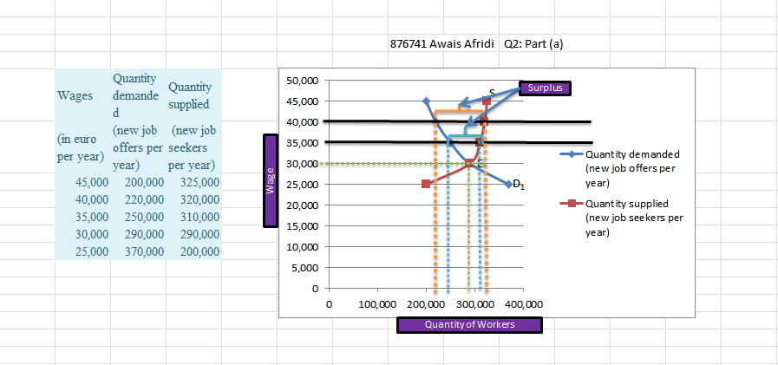

1. Suppose the French government sets a minimum yearly wage of €35,000. Is there any involuntary unemployment at this wage? If so, how much? Illustrate with a diagram. What if the [minimum wage](https://moodle.unive.it/mod/folder/view.php?id=58277) is set at €40,000? Also illustrate with a diagram.

With a minimum wage of €35,000, there is a surplus of workers of 60,000 (the quantity supplied is 310,000 and the quantity demanded is 250,000). That is, there are 60,000 workers who are involuntarily unemployed. At a minimum wage of €40,000, there is a surplus of workers of 100,000: this is the number of involuntarily unemployed workers.

c) Given your answer to part b and the information in the table, what do you think is the relationship between the level of involuntary unemployment and the level of the [minimum wage](https://moodle.unive.it/mod/folder/view.php?id=58277)? Who benefits from such a policy? Who loses? What is the missed opportunity here?

The higher the minimum wage, the larger the amount of involuntary unemployment. The people who benefit from this policy are those workers who succeed in getting hired: they now enjoy a higher wage. Those workers, who do not get hired, however, lose: if the market were allowed to reach equilibrium, more workers would be employed. Employers also lose: fewer employers can now afford to hire workers, and they need to pay higher wages. The missed opportunity is that there are workers who want to work even at a wage lower than the minimum wage and firms that would willingly hire them at a lower wage; but because the wage is not allowed to fall below the minimum wage, these hires are not made.

Q3: The market for taxi rides is characterized by the following demand and supply functions:

Qd=180-5P

Qs=4P

a) Calculate the market equilibrium and represent it graphically. Calculate the Consumer Surplus (CS), the Producer Surplus (PS) and represent them graphically.



b) Suppose that the Government imposes a quota to the supply of taxi rides equal to Q=60. Represent the new equilibrium indicating the quantity traded and the equilibrium price. Calculate again the CS and PS and compare them with those obtained in a).

answer in the above picture.

Consumer surplus reduces and Producers surplus inc

c) Propose an alternative policy which produces exactly the same results than quotas and the same distribution of surplus.

Setting a price floor

Q4: Define the pros and cons of the introduction of the [minimum wage](https://moodle.unive.it/mod/folder/view.php?id=58277) (use as reference both the textbook and the document uploaded in the "Additional material" section).

Couldn’t make it to study :D sorry